1. **Introduction**

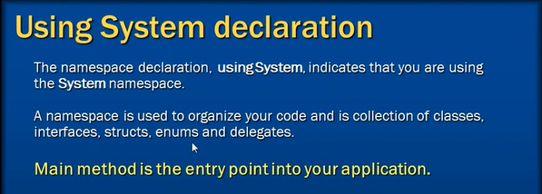

A Namespace can contain another namespace too.

1. **Reading and Writing to Console**

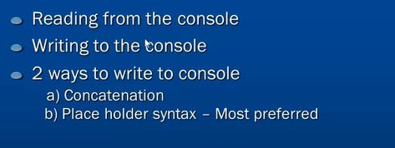

1. **Built in types**

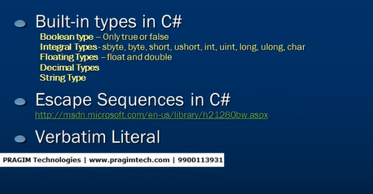

1. **String Type**
2. **Inheritance**

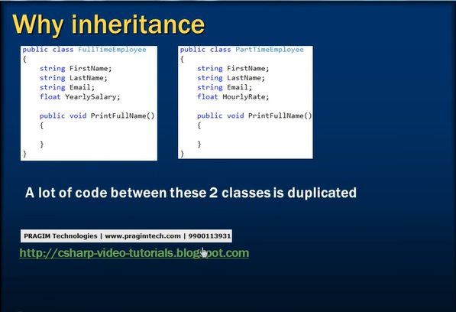

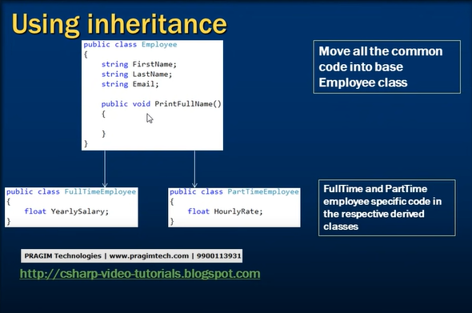

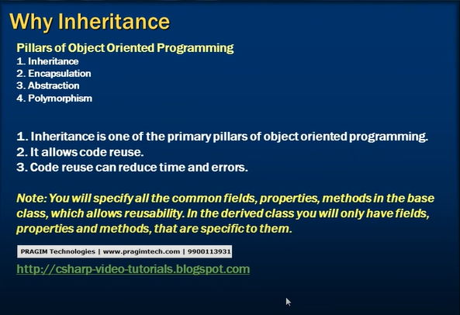

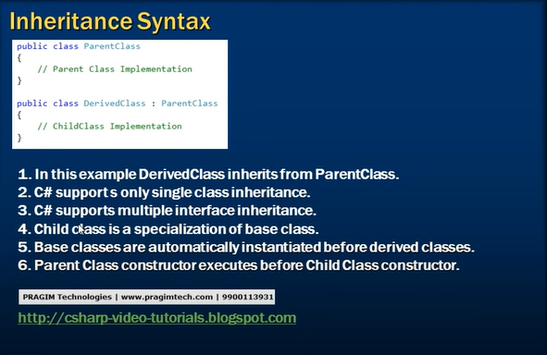 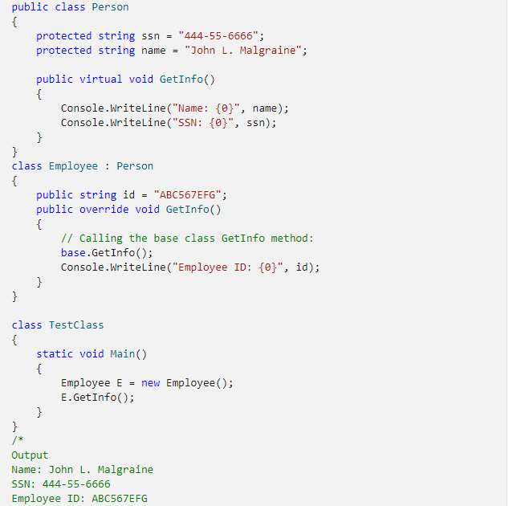

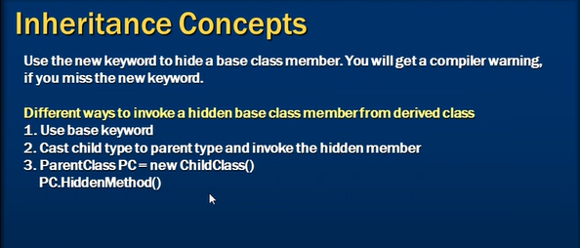

1. **Polymorphism**

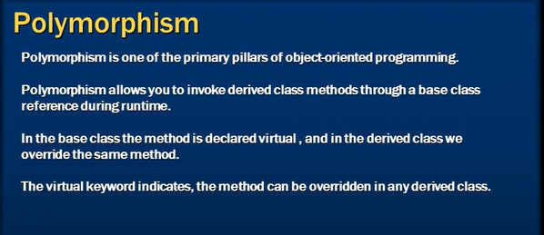

public class BaseClass

{

public void WriteNum()

{

Console.WriteLine(12);

}

public virtual void WriteStr()

{

Console.WriteLine("abc");

}

}

public class DerivedClass : BaseClass

{

public new void WriteNum()

{

Console.WriteLine(42);

}

public override void WriteStr()

{

Console.WriteLine("xyz");

}

}

/* ... */

BaseClass isReallyBase = new BaseClass();

BaseClass isReallyDerived = new DerivedClass();

DerivedClass isClearlyDerived = new DerivedClass();

isReallyBase.WriteNum(); // writes 12

isReallyBase.WriteStr(); // writes abc

isReallyDerived.WriteNum(); // writes 12

isReallyDerived.WriteStr(); // writes xyz

isClearlyDerived.WriteNum(); // writes 42

isClearlyDerived.writeStr(); // writes xyz

Overriding is the classic OO way in which a derived class can have more specific behaviour than a base class (in some languages you've no choice but to do so). When a virtual method is called on an object, then the most derived version of the method is called. Hence even though we are dealing with isReallyDerived as a BaseClass then functionality defined in DerivedClass is used.

Hiding means that we have a completely different method. When we call WriteNum() on isReallyDerived then there's no way of knowing that there is a different WriteNum() on DerivedClass so it isn't called. It can only be called when we are dealing with the object **as** a DerivedClass.

Most of the time hiding is bad. Generally, either you should have a method as virtual if its likely to be changed in a derived class, and override it in the derived class. There are however two things it is useful for:

1. Forward compatibility. If DerivedClass had a DoStuff() method, and then later on BaseClass was changed to add a DoStuff() method, (remember that they may be written by different people and exist in different assemblies) then a ban on member hiding would have suddenly made DerivedClass buggy without it changing. Also, if the new DoStuff() on BaseClass was virtual, then automatically making that on DerivedClass an override of it could lead to the pre-existing method being called when it shouldn't. Hence it's good that hiding is the default (we use new to make it clear we definitely want to hide, but leaving it out hides and emits a warning on compilation).
2. Poor-man's covariance. Consider a Clone() method on BaseClass that returns a new BaseClass that's a copy of that created. In the override on DerivedClass this will create a DerivedClass but return it as a BaseClass, which isn't as useful. What we could do is to have a virtual protected CreateClone() that is overridden. In BaseClass we have a Clone() that returns the result of this - and all is well - in DerivedClass we hide this with a new Clone() that returns a DerivedClass. Calling Clone() on BaseClass will always return a BaseClass reference, which will be a BaseClass value or a DerivedClass value as appropriate. Calling Clone() on DerivedClass will return a DerivedClass value, which is what we'd want in that context. There are other variants of this principle, however it should be noted that they are all pretty rare.

An important thing to note with the second case, is that we've used hiding precisely to **remove** surprises to the calling code, as the person using DerivedClass might reasonably expect its Clone() to return a DerivedClass. The results of any of the ways it could be called are kept consistent with each other. Most cases of hiding risk introducing surprises, which is why they are generally frowned upon. This one is justified precisely because it solves the very problem that hiding often introduces.

In all, hiding is sometimes necessary, infrequently useful, but generally bad, so be very wary of it.

1. **Method Hiding vs Method overriding**

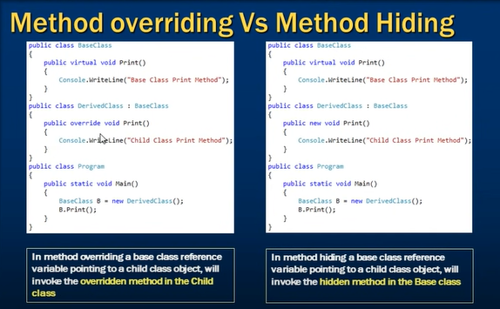

1. **Method overloading**

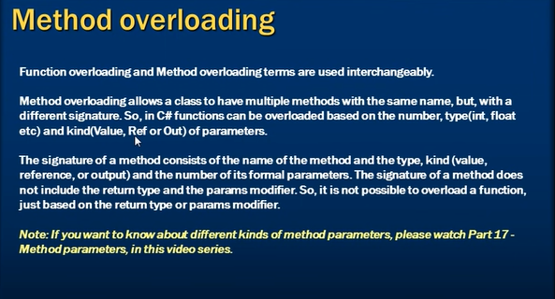

1. **Properties**

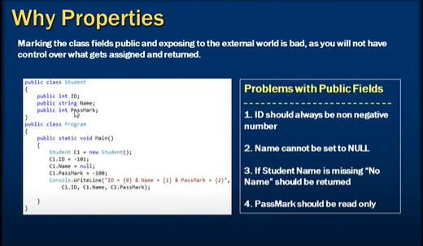

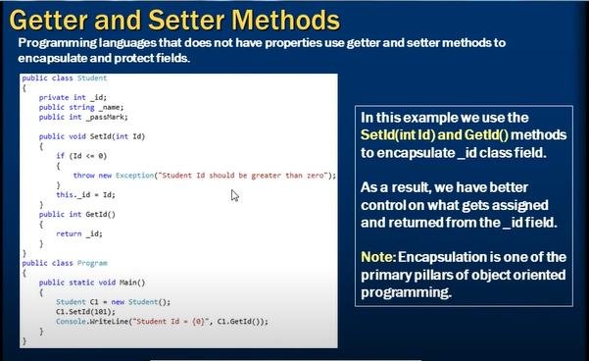

1. **Properties**

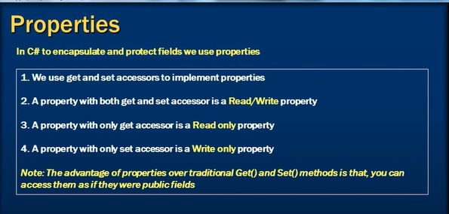

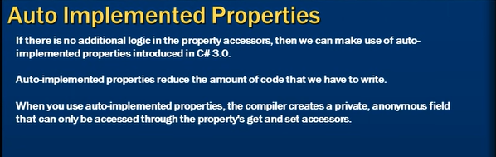

1. **Structs**

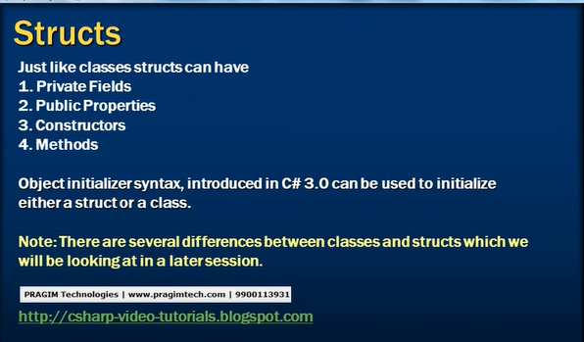

1. **Class vs Struct**

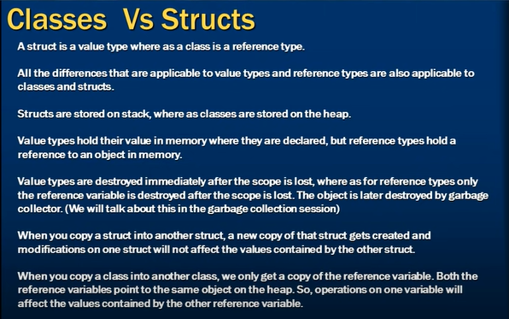

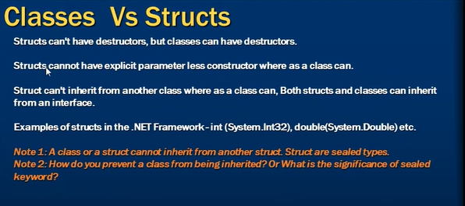

1. **Interfaces**

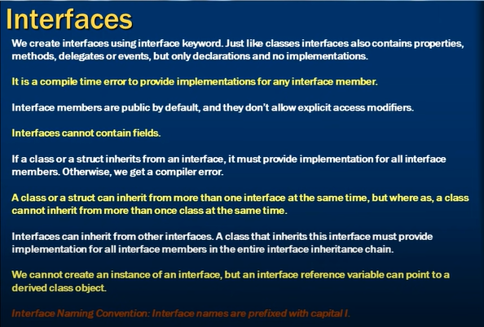

1. **Explicit Interface Implementation**

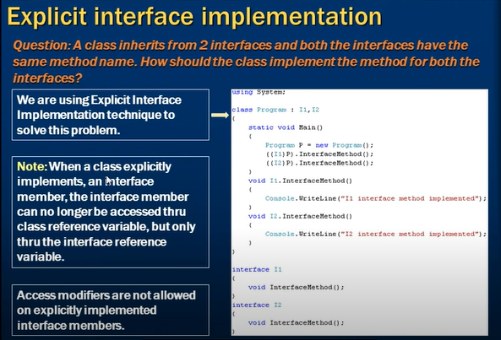

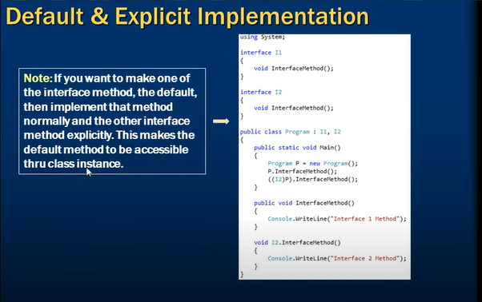

1. **Abstract Classes**

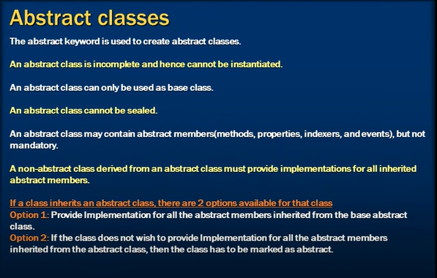

1. **Abstract Classes vs Interfaces**

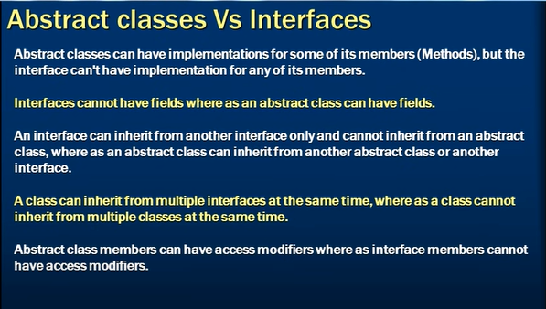

1. **Problems of multiple Inheritance**

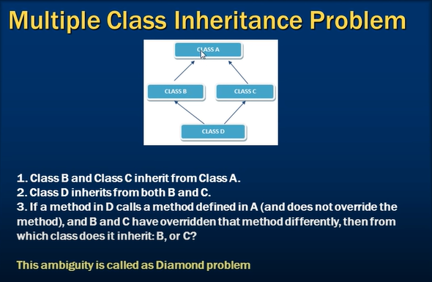

1. **Multiple class inheritance using interfaces**

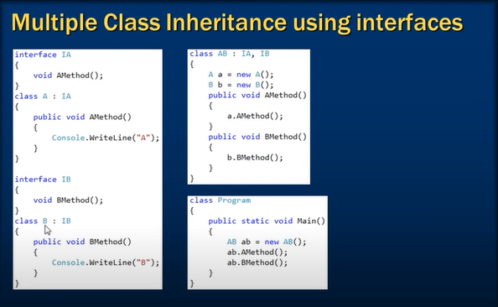

1. **Delegates**

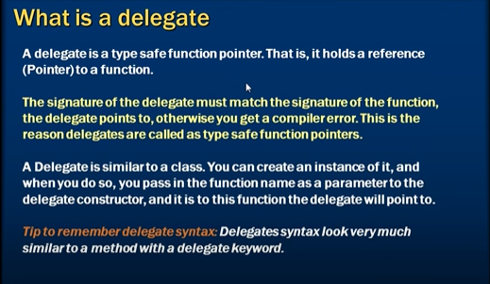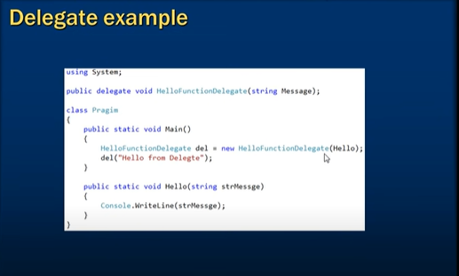

1. **Delegate Usage**

**Demo**

1. **Delegate Usage**

**Demo**

1. **Multicast Delegate**

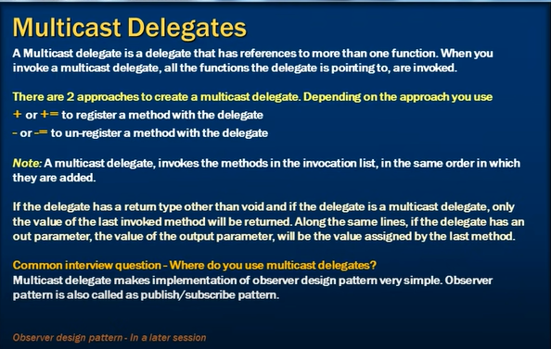

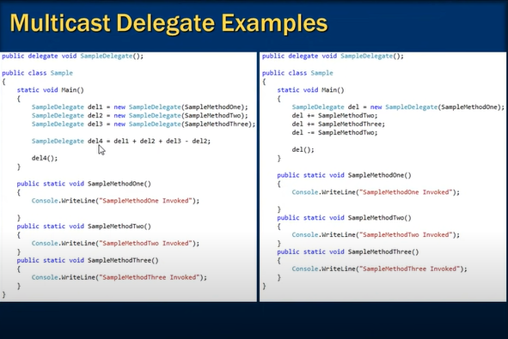

1. **Exception Handling**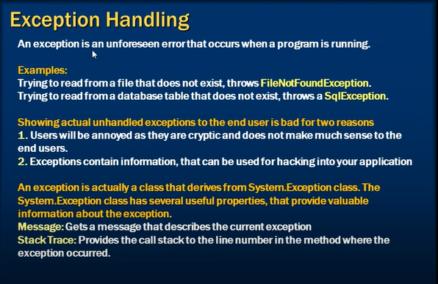

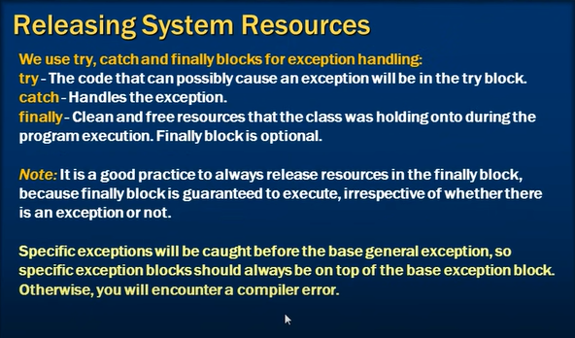

1. **Inner Exceptions**

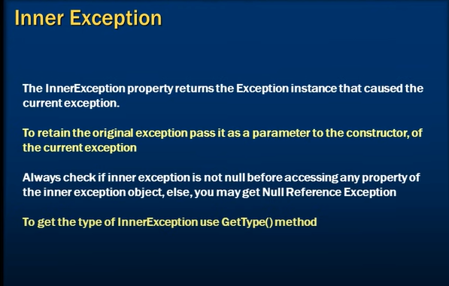

1. **Custom Exceptions**

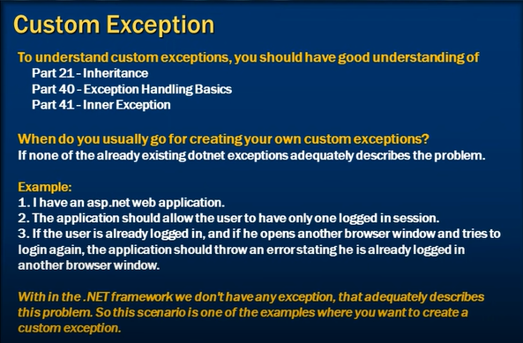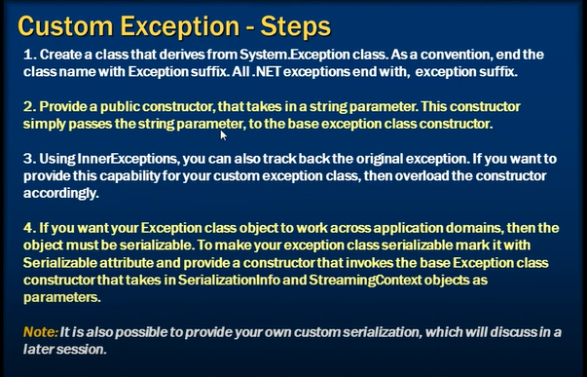

1. **Exception Handling Abuse**

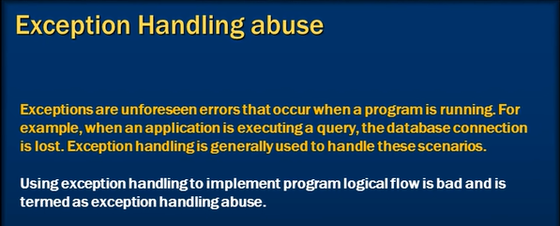

1. **Preventing Exception Handling Abuse**



1. **Enums**

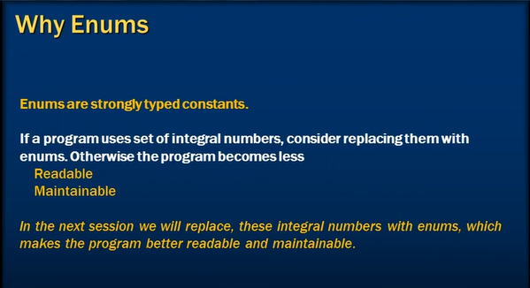

1. **Enums Example**

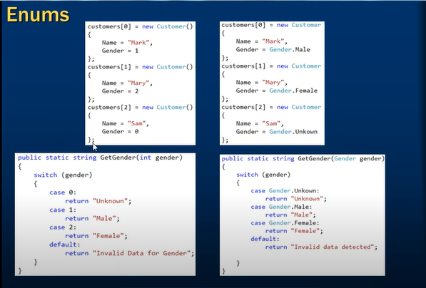

1. **Enums Tutorial**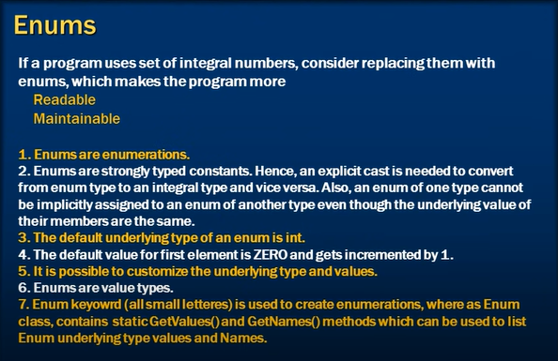
2. **Difference between Types and Type Members**

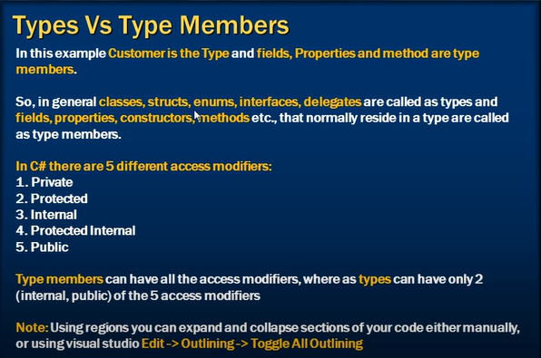

1. **Access Modifiers**

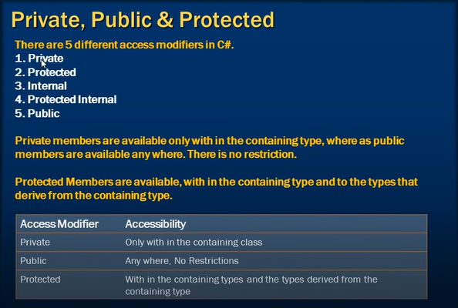

1. **Internal and Protected Internal**

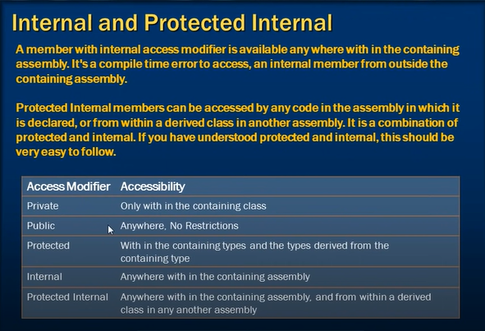

1. **Access Modifiers for Types**

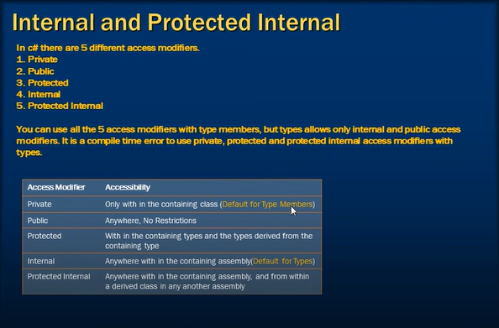

1. **Attributes**

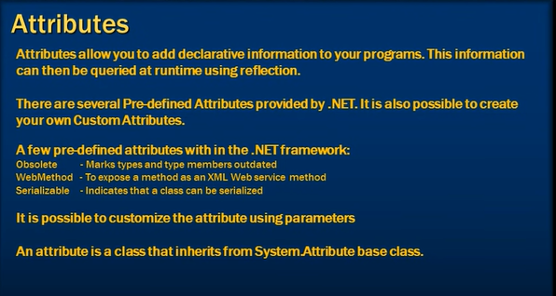

1. **Reflection**

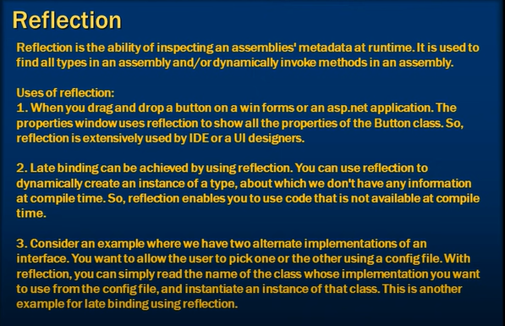

1. **Reflection Example**

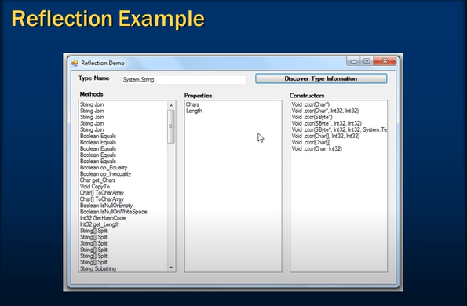

1. **Late Binding Using Reflection**

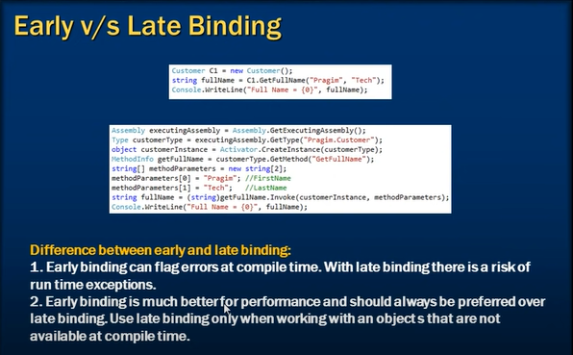

1. **Generics**

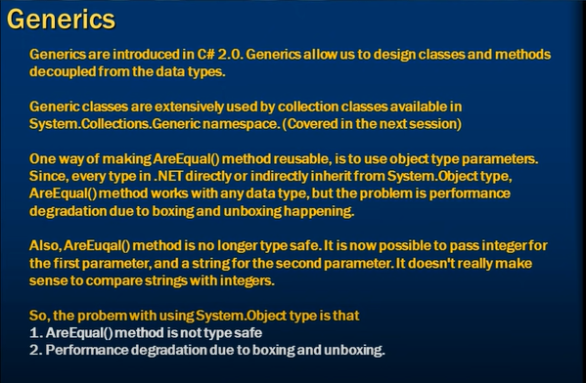

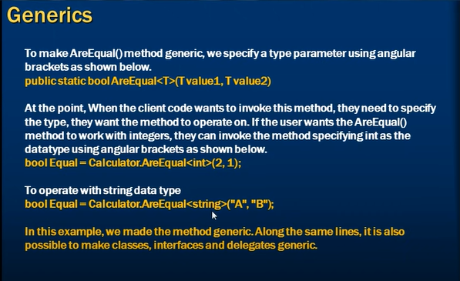

1. **Why should you override ToString method**

**Check Code**

1. **Why should we override Equals method**

**Check Code**

1. **Convert.ToString() vs ToString()**

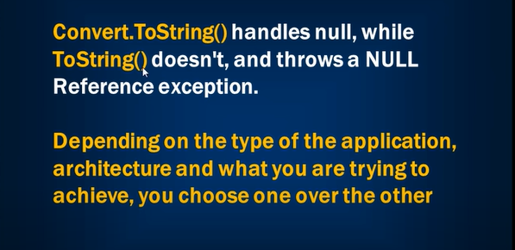

1. **Difference between System.String vs System.Text.StringBuilder**

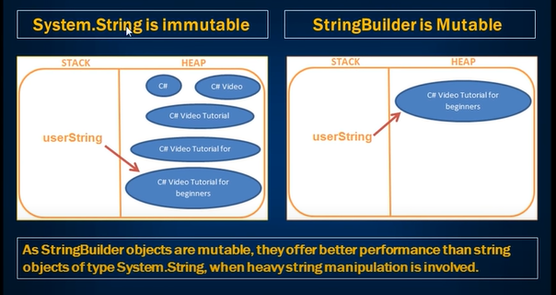

1. **Partial Classes**

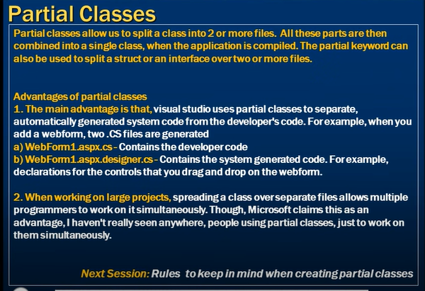

1. **Creating Partial Classes**

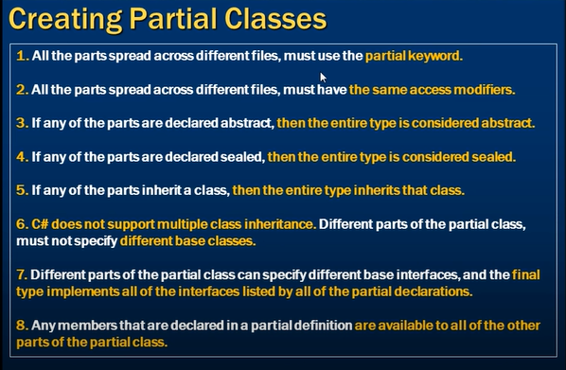

1. **Partial Methods**

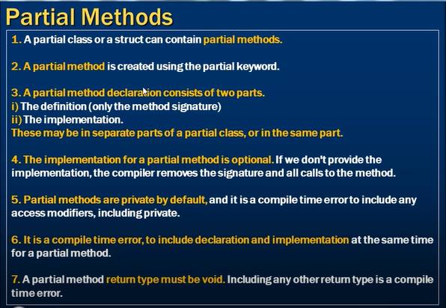

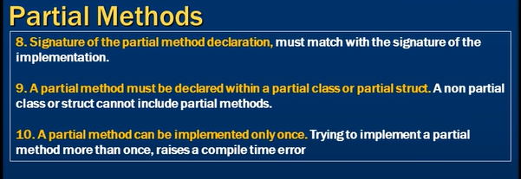

1. **Indexers**

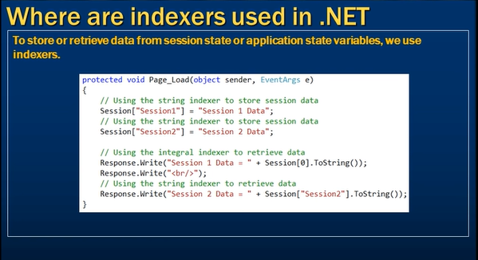

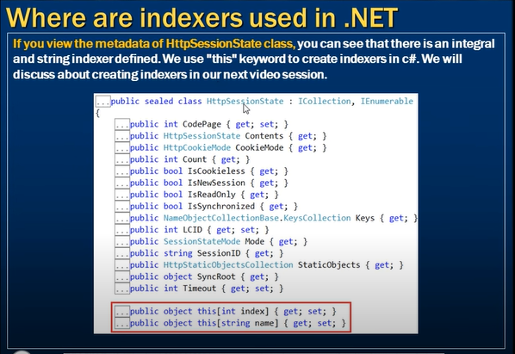

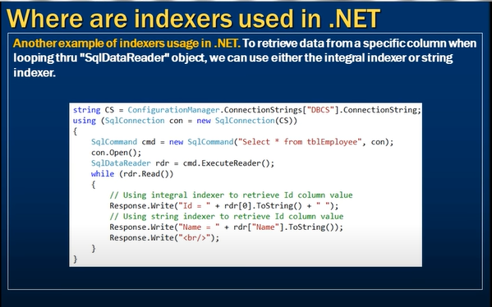

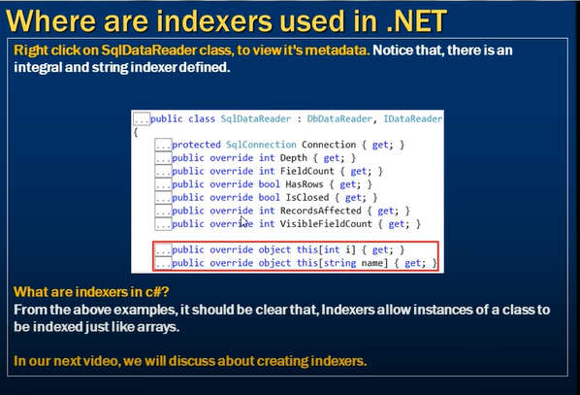

1. **Creating Indexers**

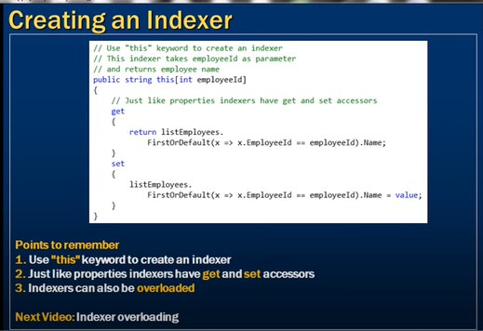

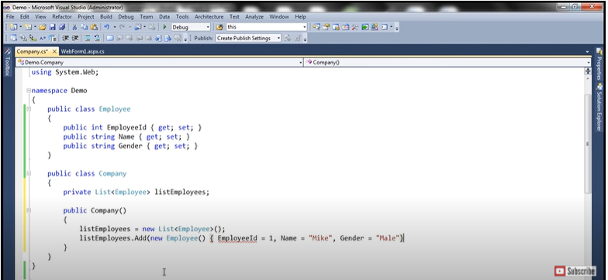

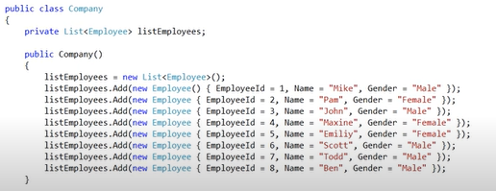

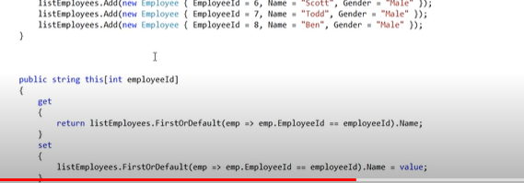

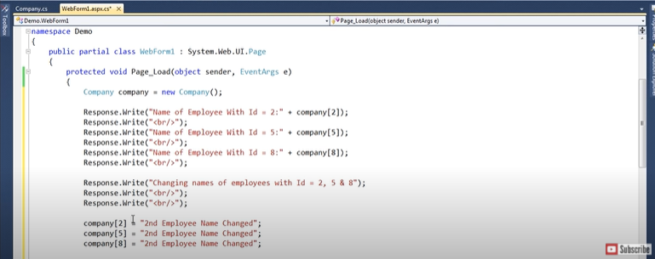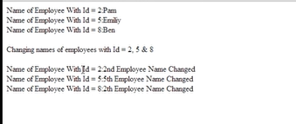

1. **Overloading Indexers**

**Continuing part 65**

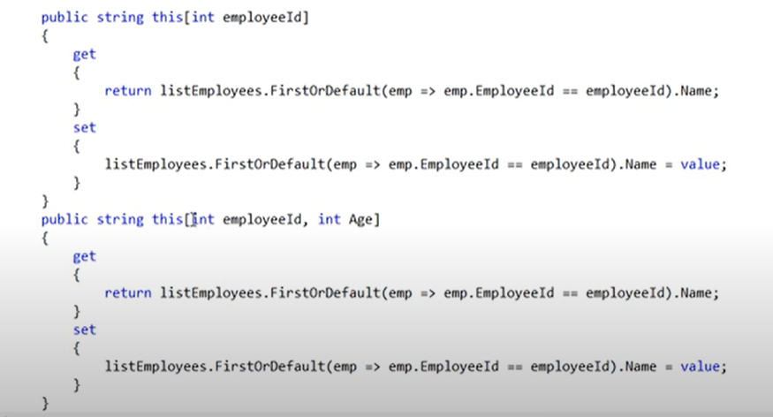

**Indexer Overloading**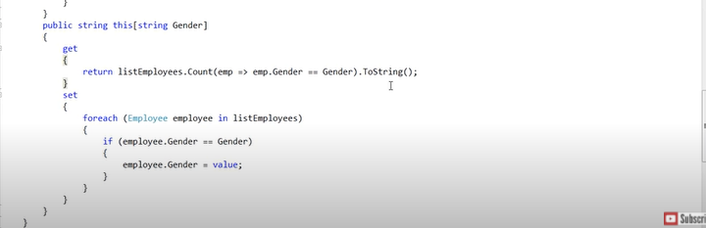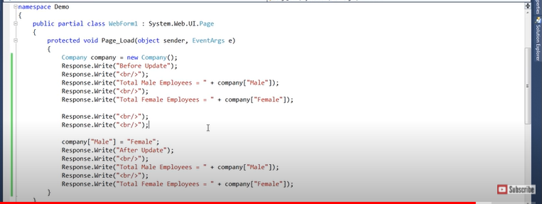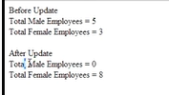

1. **Optional Parameters – using params**

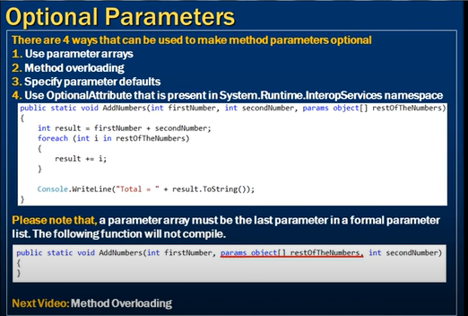

1. **Optional parameters – using method overloading**

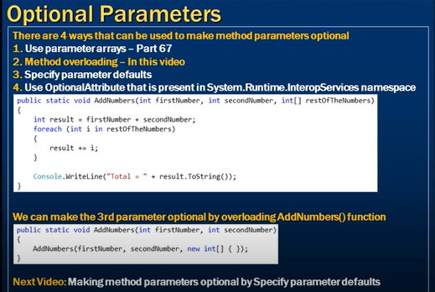

1. **Optional parameters – specifying parameter defaults**

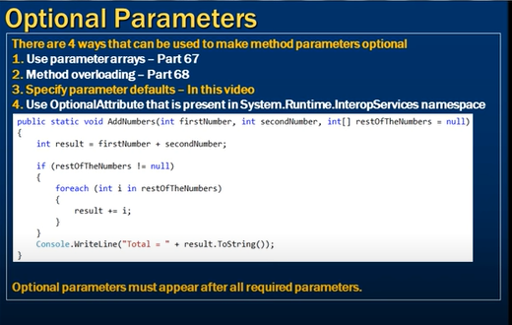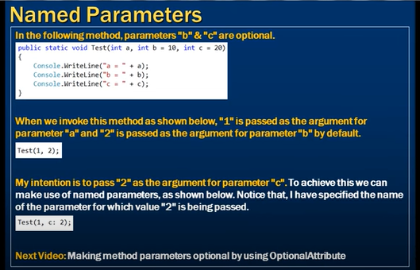

1. **Using optional attribute present in system.runtime.interopservices namespace**

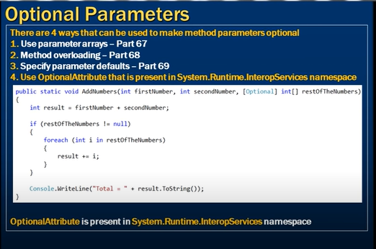

1. **Code Snippets**

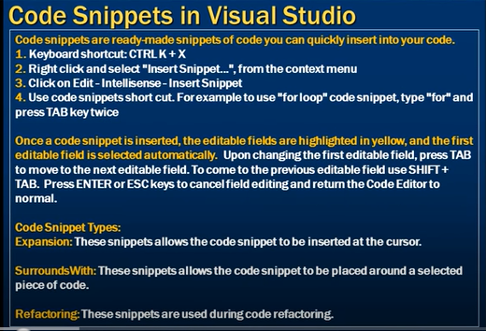

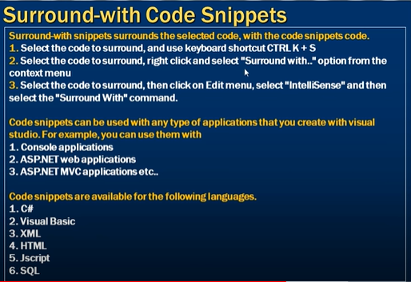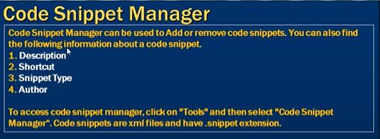

1. **Dictionary**

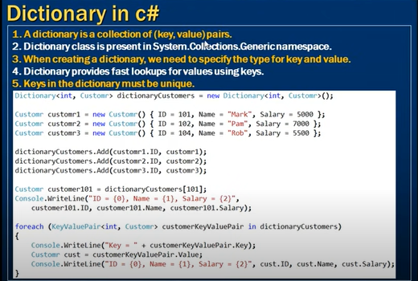

1. **Dictionary Continued**

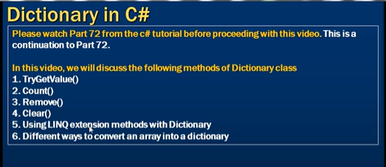

1. **List Collection**

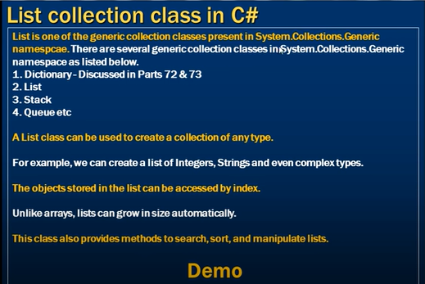

1. **List Collection – Continued**

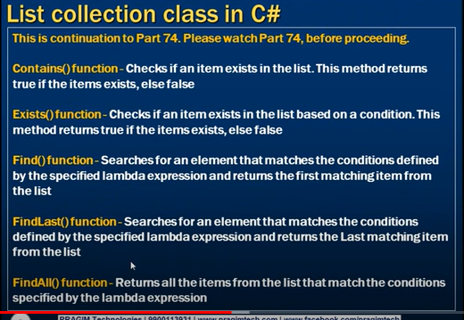

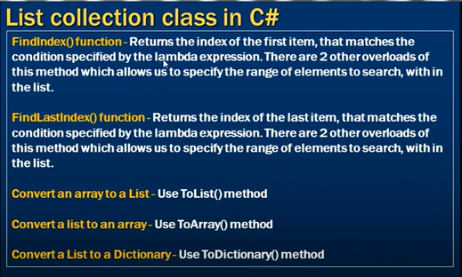

1. **Generic List class and Ranges**

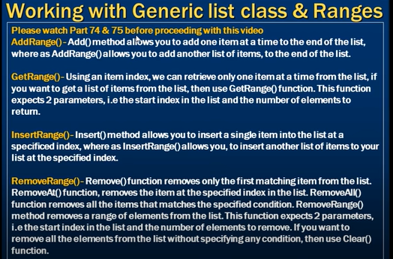

1. **Sorting a list of Simple Types**

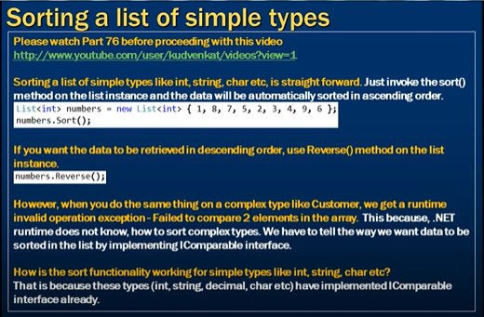

1. **Sorting a list of complex types**

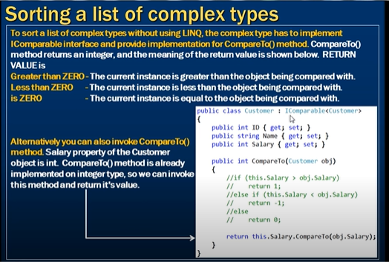

1. **Sorting a list of complex types – using comparison delegate**

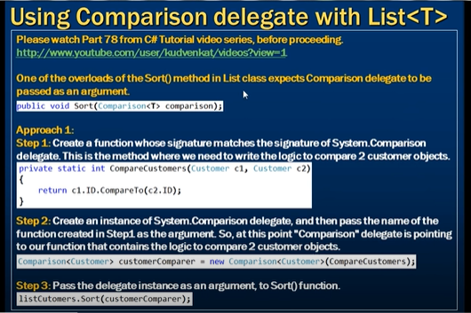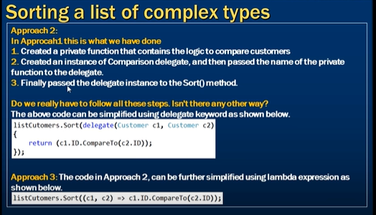

1. **Useful Methods of List collection**

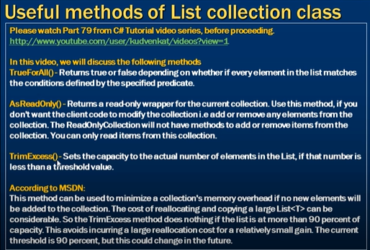

1. **When to use a dictionary over a list**

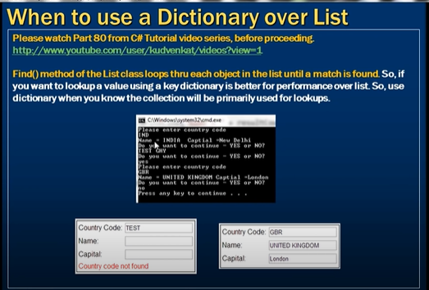

1. **Generic Queue collection class**

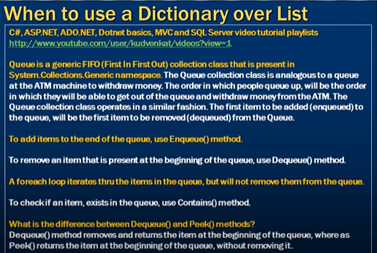

1. **Stack**

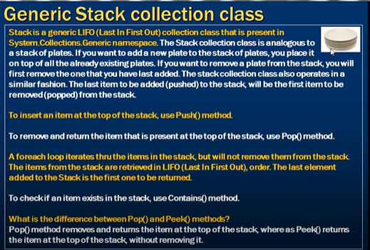

1. **Real Time example – Queue**

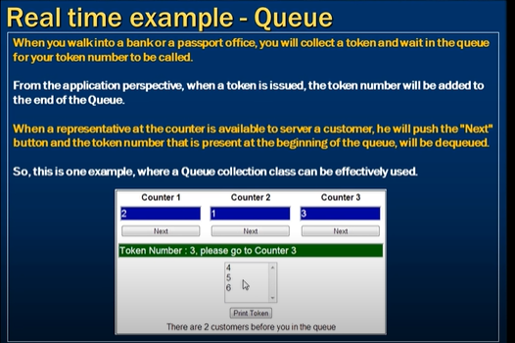

1. **Real time example – Queue**

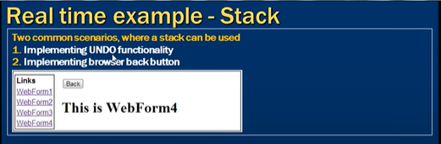

1. **Multi Threading**

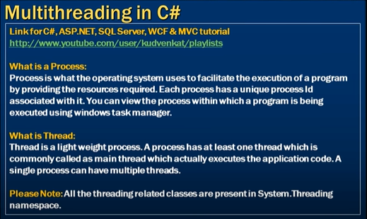

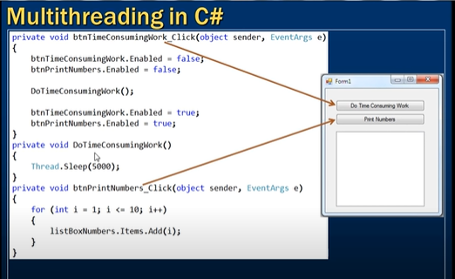

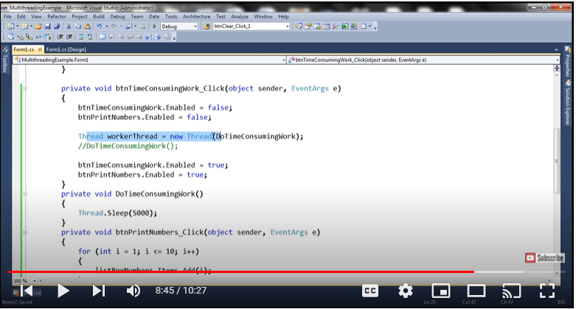

1. **Advantages and Disadvantages of multithreading**

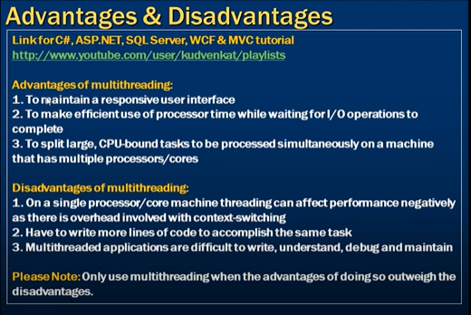

1. **ThreadStart Delegate**

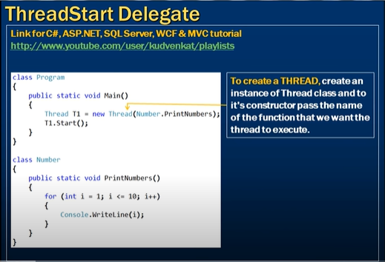

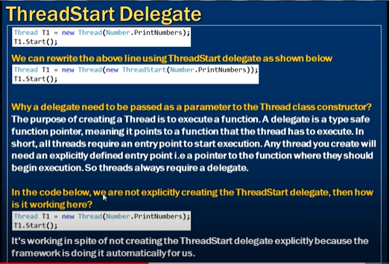

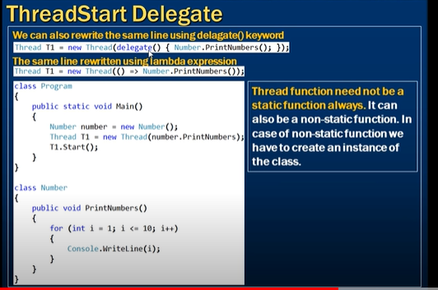

1. **Parameterized ThreadStart Delegate**

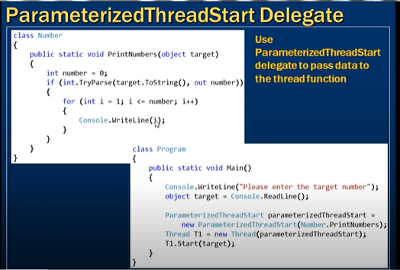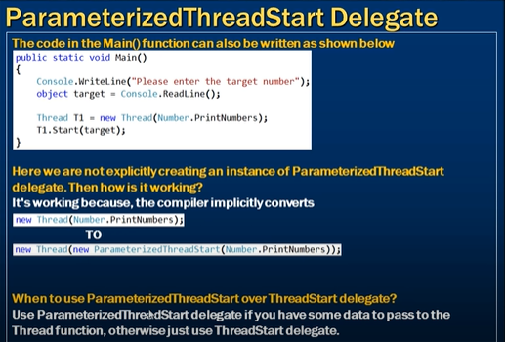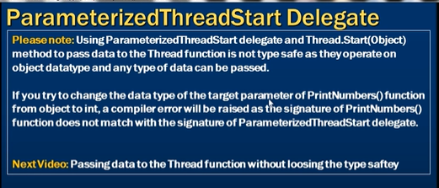

1. **Passing data to thread function in a type safe manner**

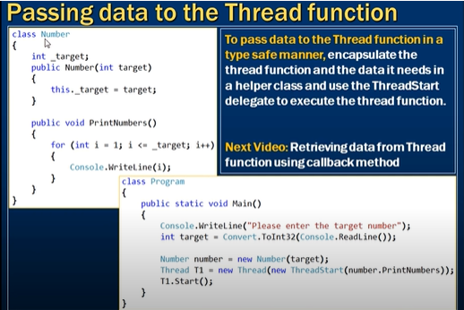

1. **Call back method to get data from thread**

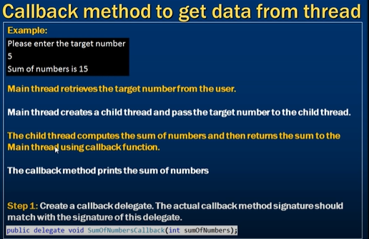

1. **Anonymous Methods**

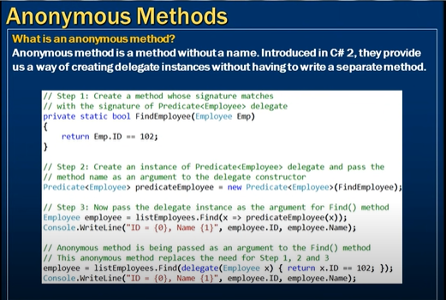

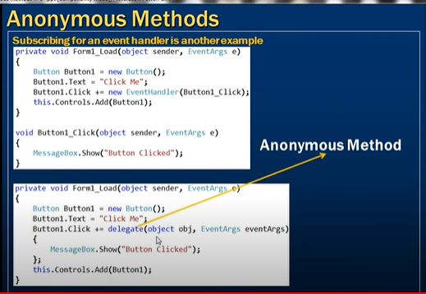

1. **Lambda Expressions**

